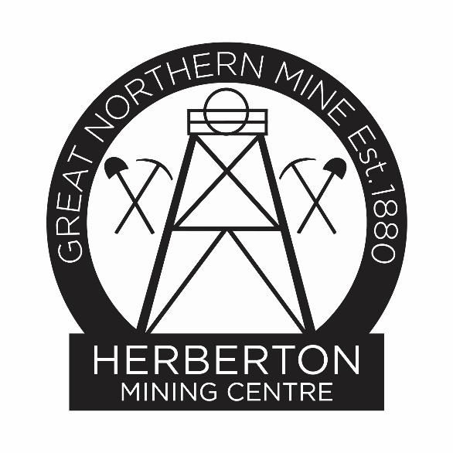
Research at the Herberton Mining Centre
The Herberton Mining Centre research team has complied resources to assist people in their research on families in the Herberton Mining Field.
HMC Resources
The following resources are available on the Herberton Mining Museum Web page: https://herbertonminingmuseum.com/research/research-resources
Mining Leases in Herberton Mineral Filed Historical Mining Leases on Herberton District
Early Herberton Newspapers
Wild River Times Vol, 19 No. 936 5th January 1901
Herberton Advertiser and Western Observer No. 55 12th July 1884
Herberton School Rolls 1880 to 1940
Secondary School rolls 1918 to 1940
Methodist Hostel and Woodleigh Residential College
Student List 1950 to 1960
Woodleigh College Enrolments at Herberton Secondary Department 1970-1976
History of Hostel and College 1926-1982
Resources available at the Research Room
Library
Mines Department files including Qld Gov Mining Journals
Social History
Archive boxes
Businesses
Cemeteries- Burial records and Location of plots in Herberton Cemetery
1914 Phone Book
WW2 Camp sites on the Tablelands info
Mt Saint Bernard student list to 2009
Herberton Shire Council Rate Books 1903 to 1949
Herberton Shire Council List of councillors
Herberton Town block addresses and lot numbers
Parish maps
Family History
Archive boxes
Pughs Almanac- Businesses in town 1881-1927
Early Herberton Newspapers
The Hodgkinson Mining News 1877-1879
Herberton Advertiser and Western Observer 1884 – 1893
Wild River Times Herberton, Watsonville, Hodgkinson & Etheridge Miner 1901-1902
External resources
Trove search on internet https://nla.gov.au
Qld State Library https://www.slq.qld.gov.au/collections/family-history
Qld State Archives - https://www.qld.gov.au/recreation/arts/heritage/archives/starting/search-the-records
Qld Births, Deaths & Marriages search on internet https://www.familyhistory.bdm.qld.gov.au/
Queensland Globe on internet
Titles Queensland www.titlesqld.com.au
Text Queensland (includes Pughs Almanac, Government Gazette)
Onesearch https://onesearch.slq.qld.gov.au/discovery/search?vid=61SLQ_INST:SLQ
Australian War Memorial https://awm.gov.au
https://www.ryersonindex.org/
https://www.qld.gov.au/firstnations/cultural-awareness-heritage-arts/family-personal-history

Paid Subscriptions
https://www.ancestry.com.au
Historical Societies
Cairns https://www.cairnsmuseum.org.au/historical-societ/research-centre/
Eacham https://eachamhistorical.wordpress.com/
Irvinebank https://irvinebank.org/loudoun-house-museum/
Mareeba https://www.mbahistsoc.org.au/
Requests to Research team
via email hmc@trc.qld.gov.au

